1(a), 2(d)
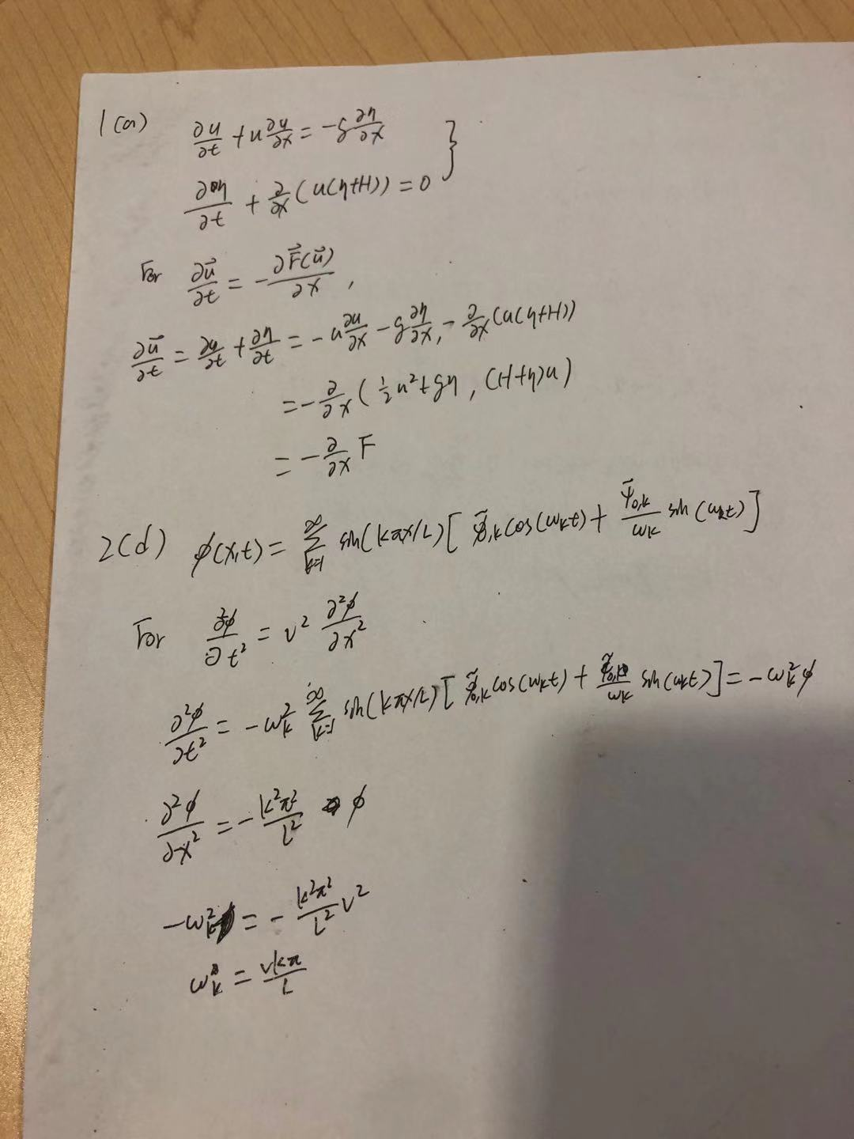

1(c)
From the plot, we can see that as the time goes, the maximum height of the peak of the tsunami is increasing. Also the thickness of the tsunami is decreasing. For the rest of the part of the ocean behind the tsunami, it’s mostly flat.

2(f)
By comparing these two graphs, we can see that the graph produced by the Fourier transformation is smoother but they are in the same shape. Since for the Fourier transformation, we only take 101 points so there are a little different from the CN method.

